- Purpose
  - The purpose of this document is to describe the procedure for assembling the handle on the Genesys Machine.
- Scope
  - This SOP applies to all equipment assembly team members. The process applies to the following machine ID’s:
EP50316EQS0600BE1200 – Handle Assembly
EP50352EQS0600BE1200 – Handle, G20 TR
EP50353EQS0600BE1200 – Handle, G20 PA
- Responsibilities
  - The operations manager/supervisor is responsible for enforcing this SOP.
- Materials
  - The proper materials needed for this process are listed on the machine work order.
- Definitions

- Procedure

  - Take a handle (E28915) and attach a handle back (E29301) using 7 torx screws (E29336). Ensure the screw heads are flush with the surface.
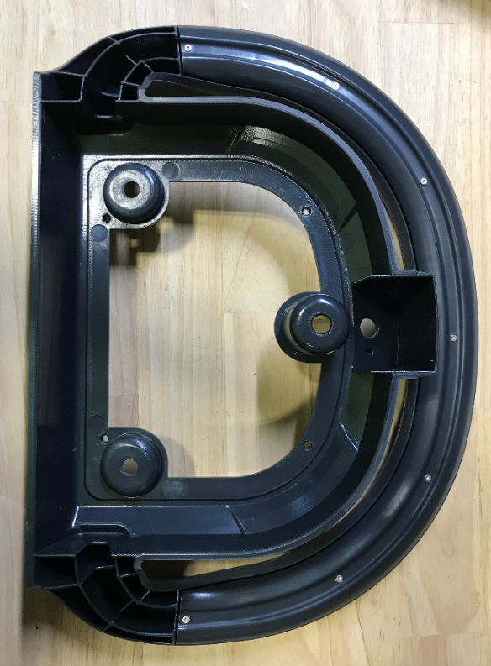

  - (For a MSAS or a G20 Traction Unit) Remove the supplied washer and nut from a potentiometer (E28955) and place a spacer (E28768) over it as shown. The tab on the potentiometer will fit into the hole on the spacer.
-For a G20 Pad Assist, skip steps 2 through 4.
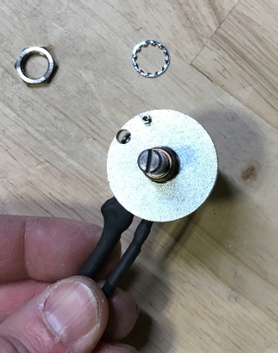
  - (For MSAS and G20 Traction Unit) Feed the potentiometer through the appropriate hole on the handle and attach it using the supplied nut and washer. The pin on the spacer fits into the dimple in the handle to locate it.
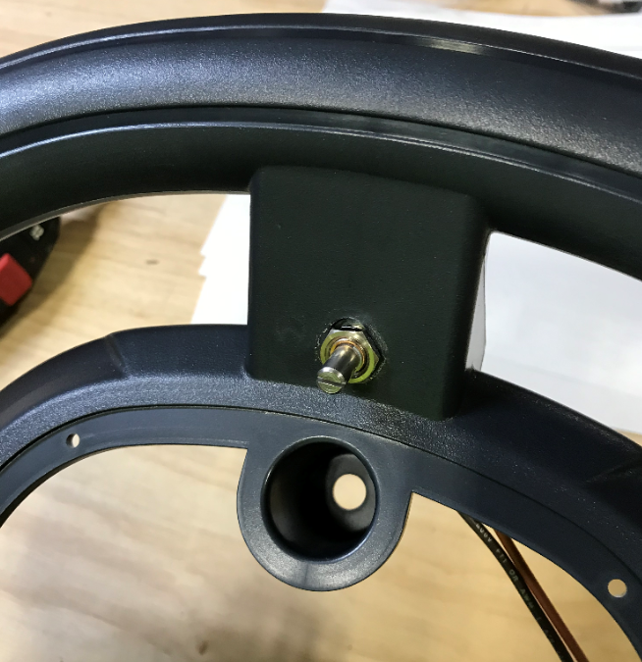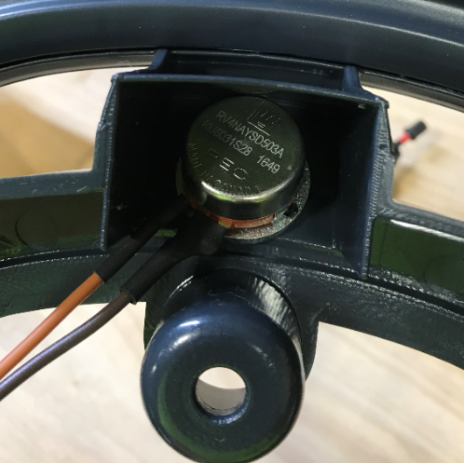

  - (For MSAS and G20 Traction Unit) Turn the shaft of the potentiometer CCW until it stops. Attach the knob (E28606) to the potentiometer. Put some blue Loctite on the set screw. Locate the line on the knob as shown in the photo. Ensure that it is properly tightened. Rotate the knob CW until it stops. The line should be roughly where it is shown in red (Should be a mirror image of where is started). If it is not, loosen and adjust.

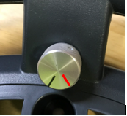

  - (For G20 Pad Assist) Install a bolt (E28824) and a nut (E11146) in place of the potentiometer.

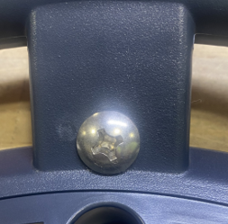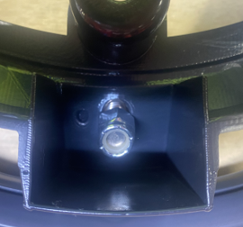

- References (optional section as needed)

- Training Guide

Functional Training Groups Requiring Training
Equipment Assembly Group

- SOP Change Control

Date of Change | Reason for Change
Rev 01 | This is the first version of the S.O.P. hence there are no revisions to this document.
Rev 02 - 3/31/2025 | Combined the MSAS and G20 instructions.

Approvals

Submitter/Author Approval:__________________________________ Date:______________________

Management Approval:______________________________________ Date:______________________

QAU Approval:_____________________________________________ Date:______________________

